# TEAM ETS

E-School PROJECT

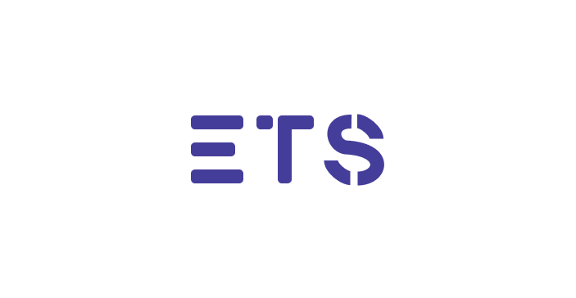

# MADE BY

ETS

FIND US ON   
GITHUB

REPOSITORY

*school-project-assignment-ets*

TABLE OF CONTENT

IDEA OF THE PROJECT 3

TEAM MEMBERS 3

PROJECT DESCRIPTION 3

PERFORMED TASKS 4

FUNCTIONS 5

BLOCK DIAGRAM 8

# IDEA OF THE PROJECT

The idea of the project is to create a game connected with the binary system called Booleo using c++.

# TEAM MEMBERS

|  |  |
| --- | --- |
| **№** | **Roles in the team** |
| **1** | Dean Petkov – Scrum trainer |
| **2** | Anton Kabakov – Back-end developer |
| **3** | Aleks Kazakov – Back-end developer |
| **4** | Todor Atanasov – Back-end developer |
| **5** | Ivan Dochev - Back-end developer |
| **6** | Lachezar Rashkov – QA Engineer |

# PROJECT DESCRIPTION

|  |  |
| --- | --- |
| **№** | **Description** |
|  | The idea in general.  The idea is to create a computer-based program connected with the binary system using C++ |
| **2** | How can you access the project?  You can find our project on GitHub. You can access the files by installing the repository or pasting this to your console - https://github.com/codingburgas/school-project-assignment-ets.git |
| **3** | Teamwork.  Our main communicating platform was Microsoft Teams. During the project, we met almost every day, so that everyone can catch up with the work. |
| **4** | What technologies are used?  The technologies we used are **Visual Studio** as our code editor, **GitHub** for collaborative work, **Microsoft Teams** for connection and communication, **PowerPoint** for creating the presentation, **Word** for creating documentation and Excel for QA documentation. |

# PERFORMED TASKS

|  |  |
| --- | --- |
| **№** | **Completed tasks** |
| **1** | Createmainmenu  When you open the program, This is the first page you see. |
| **2** | Create register page  When you want to make new account this is the tab you have to open. |
| **3** | Create Sign in page  When you have account already you have to open this tab and sign in. |
| **4** | Modify main Menu  We change the design a little to look better and to be more easy to use. |
| **5** | Modify Sign in page  We change the design a little to look better and to be more easy to use. |
| **6** | Modify register page  We change the design a little to look better and to be more easy to use. |
| **7** | Create the README file  In the readme file, you can get a quick overview of the project. We have added the programming languages we have used. |
| **8** | Make the documentation  The documentation provides very useful information in terms of the technical aspect. You can learn pretty much everything by reading it. |
| **9** | Make the presentation  We have created a short presentation to quickly show what we have done. |

# BLOCK DIAGRAM